Task 1: Diagram Showing How a Phone Connects to Instagram Servers
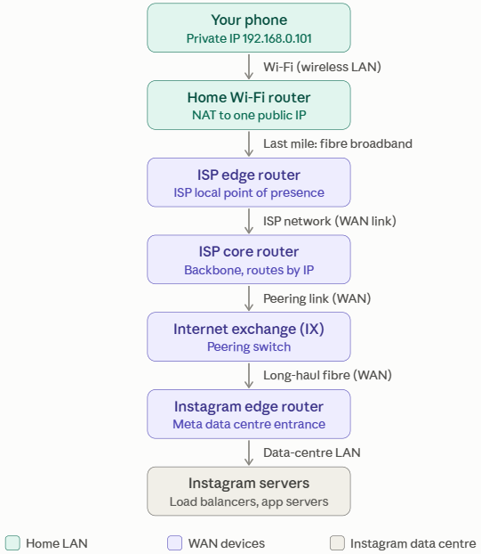
Path Component Breakdown:
- Smartphone (Client Device): Originates the outbound
application request (e.g., loading an Instagram feed).
- Home Wi-Fi Router: Serves as the local default gateway,
bridging wireless frames to wired media and translating
private IPv4 addresses to a public IP using Network Address
Translation (NAT).
- WAN Device 1 (ISP BNG / Edge Access Router): Terminates
the subscriber's local broadband link, authenticates session
credentials (e.g., PPPoE/IPoE), enforces bandwidth policies,
and routes traffic into the provider’s regional wide area
network.
- WAN Device 2 (Core Backbone Router / IXP Peering
Gateway): High-capacity optical router operating inside the
provider core or an Internet Exchange Point (IXP), exchanging
packets between autonomous systems via Border Gateway
Protocol (BGP).
- Instagram Destination Edge Server: Terminates the secure
TLS session and delivers feed assets back through the WAN
path.

Task 2: Comparison of WAN Technologies

WAN Technology | Typical Speeds / Bandwidth | Relative Cost | Real-World Use Case Example | Key Operational Characteristic
Broadband Internet (Fiber FTTH / Cable) | 100 Mbps – 1 Gbps+ (asymmetrical or symmetrical) | Low (roughly ₹500 to ₹1,500 per month for home plans) | Home Wi-Fi Setup / Small Cafés: Everyday web browsing, streaming on YouTube, and ordering via Zomato. | Delivered over shared public infrastructure with best-effort traffic routing; lack of end-to-end Quality of Service (QoS) guarantees.
MPLS (Multiprotocol Label Switching) | 10 Mbps – 10 Gbps (strictly symmetrical) | High (charged per Mbps, much more than broadband) | IRCTC Ticketing Terminals / Banking ATM Networks: Linking rail counters or bank branches to core servers. | Employs short path labels instead of long routing table lookups; provides strict SLAs, guaranteed low jitter, and prioritization for mission-critical operations.
Dedicated Leased Line (Point-to-Point / Dark Fiber) | 1 Gbps – 100 Gbps+ (uncontended symmetrical) | Very High (Highest overall, since it is a managed service with SLAs) | Zomato Corporate HQ to Core Data Center: High-volume analytics synchronization and internal build servers. | Unshared, uncompressed physical line reserved exclusively for a single tenant, ensuring consistent line-rate throughput and zero packet contention.

TASK 3: HOW A VPN USES A WAN TO PROTECT YOU ON PUBLIC WI-FI

A VPN builds a private, encrypted tunnel across a public WAN (the internet), so your traffic stays protected even on a shared coffee-shop network.
- On public Wi-Fi, the café’s router, and anyone else on that network, can see or tamper with your traffic. A fake hotspot could also sit in the middle.
- When you turn on the VPN app, it connects to a VPN server somewhere on the internet and agrees encryption keys with it (using protocols such as WireGuard, OpenVPN or IPsec).
- Private Tunnel Creation (Encapsulation): When accessing services like Spotify or YouTube, the client VPN software intercepts the outgoing network packets. Instead of transmitting them in clear text, it wraps (encapsulates) the entire original packet—including headers and payload—inside a new outer IP packet addressed directly to a remote VPN gateway router.
- End-to-End Cryptographic Protection: The internal packet is encrypted using protocols such as IPsec or WireGuard before leaving the device. As this traffic passes through the local router, ISP switches, and public transit WAN routers, intermediate nodes can inspect only the outer delivery headers.
- Across the café Wi-Fi and the ISP’s WAN, observers see only encrypted data going to the VPN server, not which app or site you use or what you send.
- Egress at the VPN Gateway: When the outer packet reaches the remote VPN server, the server strips off the external wrapper, decrypts the original payload, and routes the request onto the destination application servers (Spotify/YouTube) using its own public IP. The reply returns to the VPN server, which encrypts it and sends it back through the tunnel to your device.

Task 4: WAN Architecture Proposal for Flipkart Warehouses

Recommendation: SD-WAN over Redundant Dual Broadband / Direct Leased Lines (or MPLS with SD-WAN Overlay)
To interconnect fulfillment centers located across Ahmedabad, Mumbai, and Delhi, a Software-Defined Wide Area Network (SD-WAN) deployment backed by dual carrier-grade uplinks provides the optimal balance of availability, throughput, and operational control.
Justifications:
- Intelligent Dynamic Multi-Path Steering & High Availability: E-commerce fulfillment centers handle high volumes of barcode scans, inventory updates, and real-time shipping manifests. SD-WAN continuously evaluates packet delay, jitter, and loss across multiple WAN uplinks simultaneously. If a primary fiber link between Ahmedabad and Mumbai experiences degradation, SD-WAN dynamically reroutes ERP and database replication traffic over secondary links without dropping active workstation sessions.
- Centralized Cloud Orchestration & Cost Optimization: Traditional point-to-point leased lines or MPLS circuits across three distant metropolitan areas introduce substantial recurring expenses and require manual on-site configuration at each location. SD-WAN abstracts the physical transport layer, enabling Flipkart's central IT operations to manage routing rules, zero-trust security profiles, and QoS policies across Ahmedabad, Mumbai, and Delhi from a single pane of glass while avoiding reliance on costly, single-provider private circuits.

